


Korea Lunar Exploration Program
DTNPL Software Test Results

Date: 28 Dec. 2017 | Doc. No: KPLO-D0-550-203  Issue: 1.0  Total page: 18

Superseding Revised

Prepared By:  Hyun-Woong Choi Date  DTN SBC S/W Engineer, Lumir  Dae-Soo Oh Date  DTN SBC Engineer, Lumir |  | Kyung-Rak Lee Date  DTN Payload Engineer, ETRI
Reviewed By:  Jin-Ho Jo Date  DTN System Engineer, ETRI |  | Sin-Ae Ji Date  Proximity-1 System Engineer, ETRI
Sang-Man Moon Date  RLE KPLO Electrical System, KARI |  | Hyun-Jin Shin Date  RLE KPLO Mechanical System, KARI
Approval Signature:  Byoung-Sun Lee Date  DTN Project Leader, ETRI |  | Il-Young Kim Date  RLE KPLO Product Assurance, KARI
Seong-Bin Lim Date  Head, Lunar Exploration System Team, KARI |  | Seok-Weon Choi Date  Director, Lunar Exploration Program Office, KARI

Original CDMO Release__________________

Revision History
Version | Author(s) |  | Date | Description
0.1 | Hyun-Woong Choi |  | 2017. 12. 28 | Draft

Revision/Change Records
Version | Date | Revision/Change Description | Pages
0.1 | 2017. 12. 28 | Initial | All

Documents Tree

Contents

1. Introduction 8
1.1. Purpose and Scope 8
1.2. Applicable Documents 8
1.2.1. ETRI Documents 8
1.2.2. Other Documents 8
1.3. Abbreviations 8
2. Overview of KPLO DTN 10
2.1. DTN and Space Communications 10
2.2. Mission of DTN Operation 10
2.3. DTN Configurations 10
2.4. Communication Nodes 11
2.4.1. DTN nodes 11
2.4.2. Non-DTN nodes 11
3. Test Configuration 12
3.1. Pass/Fail Criteria 12
3.1.1. TC Verification 12
3.1.2. Functional Test 12
4. Software Test Result 13
4.1. Run time test 13
4.2. TMTC Test 13
4.2.1. Telecommand Test 14
4.2.2. Telemetry Test 15
4.3. USART Communication 16

Figures

Figure 2.1 DTN test configuration in the first phase 11
Figure 4 DTNPL Test Configuration 12
Figure 5 run time test result 13
Figure 6 UART Result 13
Figure 7 USART Communication Result 17

Tables

Table 4-1 DTNPL Command Data Structure 14
Table 4-2 DTNPL Command Data Structure 14
Table 4-2 DTNPL Telemetry Lists 15

Introduction

Purpose and Scope
This document defines the electrical and mechanical interfaces between KPLO bus and DTN payload.

Applicable Documents

ETRI Documents
Document Number | Document Title
KPLO-D0-550-000 | System Requirement of DTN Payload
KPLO-D0-550-001 | System Specification of DTN Payload

Other Documents
Document Number | Document Title
KPLO-SP-310-001 | KPLO System Specification Document
KPLO-SP-340-001 | KPLO Payload/Spacecraft Bus ICD

Abbreviations
AMS | Asynchronous Message Service
BP | Bundle Protocol
BSS | Bundle Streaming Service
CCSDS | Consultative Committee for Space Data Systems
CFDP | CCSDS File Delivery Protocol
DCC | DTN Control Center
CRC | Cyclical Redundancy Check
DMA | Direct Memory Access
DTN | Delay(Disruption) Tolerant Network
DTNPL | DTN Payload
EOD | End of Data
EOF | End of File
FW | Firm Ware
FSW | Flight Software
ION | Interplanetary Overlay Network
KDSA | Korea Deep Space Antenna
KPLO | Korea Pathfinder Lunar Orbiter
LCM | Lander Communication Model
LTP | Licklider Transmission Protocol
MOC | Mission Operation Center
OBC | On Board Computer
OBT | On Board Time
PDHU | Payload Data Handling Unit
RCM | Rover Communication Model
RFU | Reserved for Future Use
SBC | Single Board Computer
SOD | Start of Data
SOF | Start of File
SOH | Start of Head
TBC | To Be Confirmed
TBD | To Be Defined
TC | Tele-command
TCP | Transmission Control Protocol
TM | Telemetry
UART | Universal Asynchronous Receiver Transmitter
USRT | Universal Synchronous Receiver Transmitter

Overview of KPLO DTN

DTN and Space Communications
Delay/disruption tolerant networking (DTN) technology offers a new solution to highly stressed communications in space environments, especially those with long link delay and frequent link disruptions in deep space missions. Delay/disruption tolerant networking (DTN) technology offers a new solution that use a store-and-forward mechanism to combat long link delay and frequent link disruptions generally characterizing space communications. DTN communications use a bundle protocol (BP), to construct a store-and-forward overlay network. The BP, situated at the application layer of the Internet model, utilizes conventional Internet protocols to send and receive data bundles. The benefits of DTN communications are as follows.
- Interoperability and Reuse: A standardized DTN protocol suite enables interoperability of multi-agency communication assets and also allows NASA to use the same communication stack for future missions (LEO, NEO or Deep Space).
- Space Link Efficiency, Utilization and Robustness: DTN enables more reliable and efficient data transmissions resulting in more usable bandwidth. DTN also improves link reliability by having multiple network paths and assets for potential communication hops.
- Security: The DTN Bundle Security Protocol (BSP) allows for integrity checks, authentication and encryption, even on links where not previously used.
- Quality of Service: The DTN protocol suite allows for many priority levels to be set for different data types, ensuring that the most important data is received ahead of less important data.
- Improved Operations and Situational Awareness: The DTN store-and-forward mechanism along with automatic retransmission provides more insight into events during communication outages and significantly reduces the need for ground-based scheduling.

Mission of DTN Operation
The mission of DTN is to validate DTN communication protocols by space link testing through KPLO. So DTN operations are focused on testing the DTN protocols using KPLO space links.

DTN Configurations
In the first phase of lunar exploration, test lunar orbiter called Korea Pathfinder Lunar Orbiter (KPLO) will be launched without lunar lander. Figure 2.1 shows DTN configuration in first phase of lunar exploration. There are no Lander and Rover on the moon in first phase. So Lander Communication Model (LCM) and Rover Communication Model (RCM) will be located on earth for the DTN communication testing.
DTN Payload (DTNPL) is a DTN node in the space. DTNPL will be mounted on the KPLO for DTN communication. DTN Control Center (DCC) is a control center of DTN communication nodes. LCM and RCM are DTN nodes on ground. All DTN nodes on ground are interconnected by the terrestrial network such as Internet. Mission Operation Center (MOC) and Korea Deep Space Antenna (KDSA) are not DTN nodes. They just transfer DTN packets to next communication nodes.

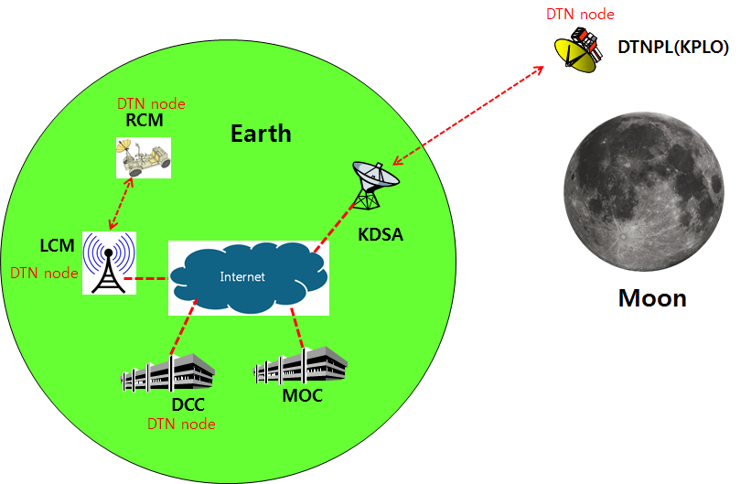
Figure 2.1 DTN test configuration in the first phase

Communication Nodes
Many communication nodes are needed for the DTN operation. Some of communication nodes in the network are DTN nodes whereas otherwise nodes are non-DTN nodes. The function of communication nodes used in the DTN operation is as follows.

DTN nodes
- DCC is a ground DTN node which monitor and controls DTN nodes. DCC send commands to DTN nodes such as DTNPL, LCM and RCM. It also receives telemetries or acquired data from some DTN nodes such as RCM or LCM.
- DTNPL is a DTN node mounted on the KPLO. DTNPL can be operated as a DTN end point. And it also can be operated as relay nodes which relay DTN data between DCC and RCM or LCM.
- LCM is a ground DTN node. LCM relays DTN data between MOC and RCM.
- RCM is a ground DTN node and a DTN end point. The commands sent by the DCC is terminated at the RCM and the RCM returns telemetry or data to DCC through KPLO.

Non-DTN nodes
- MOC is a non-DTN node. MOC monitors and controls KPLO and payloads. MOC also receives and processes data generated from the payloads and transfers to each payload control center.
- KDSA is a ground station for deep space communication. KDSA will have a big size of antenna and RF equipment for space link interface. KDSA also has network equipment for terrestrial communication interface such as SLE link. KDSA is a non-DTN node.

Test Configuration
DTN EGSE will be used to test all the software functionalities and performances. The test configuration is shown on below.

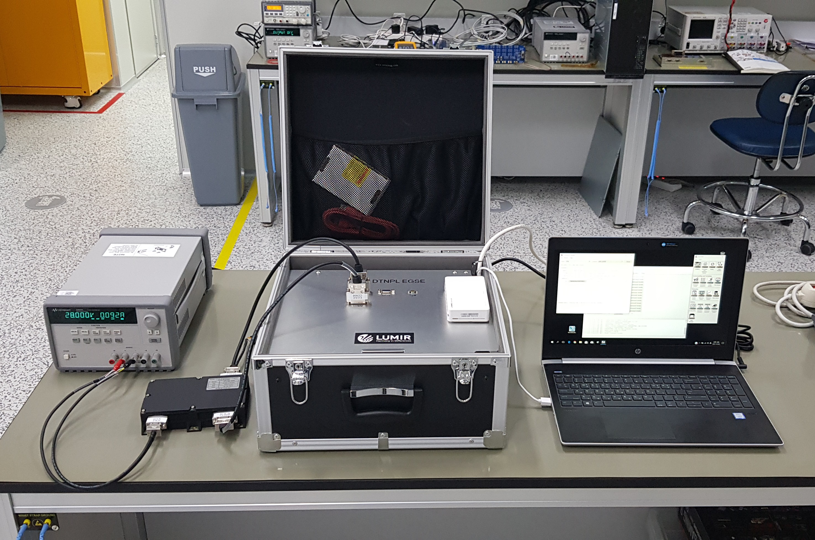
Figure 3.1 DTNPL Test Configuration

Pass/Fail Criteria
Pass/Fail Criteria will set up to test DTNPL. The criteria is divided into two parts TC verification and functional test.

TC Verification
TC verification is used to define whether the telecommand is valid or not. DTNPL EGSE can be used as an OBC and send telecommands. The DTNPL EGSE must receive expected response from DTNPL.

Functional Test
The functional test can be performed after telecommand verification is done. During this test, the task execution time will be measured.

Software Test Result

Run time test
This test guarantee that the software is able to run more than 48 hours. Simple increment test code is designed to perform run time test. The software ran more than 48 hours and the result is shown below.
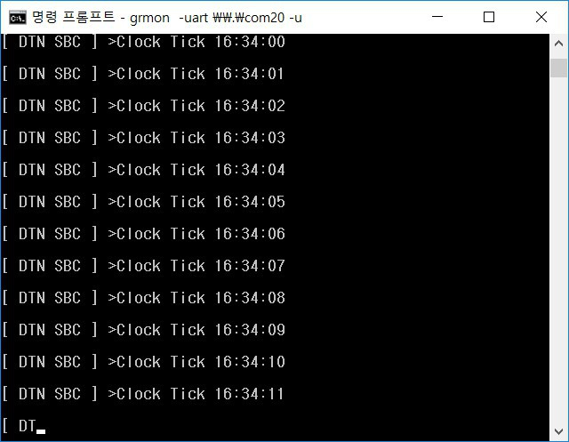
Figure 4.1 run time test result

TMTC Test
The UART is used to communicate between OBC and SBC. The communication result is shown below.

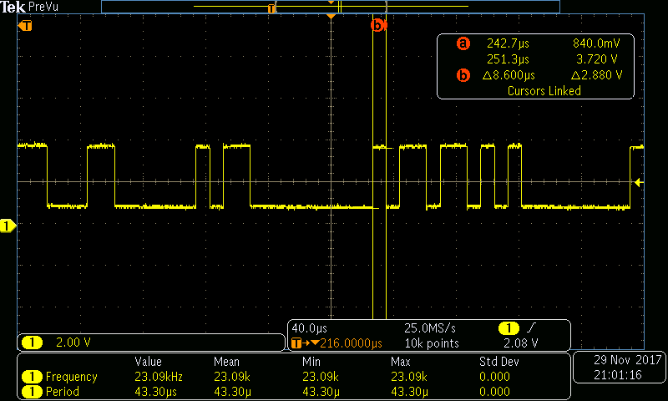
Figure 4.2 UART Result

Telecommand Test
The list of tested telecommand is shown below.
Table 4-1 DTNPL Command Data Structure
Type | Name | Sync | Length | Command | Data
 |  |  |  |  | Packet No | Payload Data
SBC TC | Echo test | 0xAA | 0x02 + Payload Data length | 0x00 | 0x0000 | variable
SBC TC | SW initialize | 0xAA | 0x02 | 0x01 | 0x0000 | None
SBC TC | Time setting | 0xAA | 0x08 | 0x02 | 0x0000 | OBT  - week since 2000-01-01 12:00:00 UTC (2 byte)  - octant second (4 byte)
SBC TC | SOH request | 0xAA | 0x02 | 0x13 | 0x0000 | None
SBC TC | Script (ionstart) | 0xAA | 0x0E | 0x04 | 0x0000 | Script command (12 byte)
SBC TC | Script (killm) | 0xAA | 0x09 | 0x05 | 0x0000 | Script command (7 byte)
SBC TC | DCC data | 0xAA | 0x02~0x43 | 0x06 | 0x0000 ~ 0xFFFF | DCC TC/data (0 ~ 65 byte)
SBC TC | RFU1 | 0xAA | 0x2A | 0x07 | 0x0000 | Reserved (40 byte)
SBC TC | RFU2 | 0xAA | 0x2A | 0x08 | 0x0000 | Reserved (40 byte)
SBC TC | RFU3 | 0xAA | 0x2A | 0x09 | 0x0000 | Reserved (40 byte)
SBC TC | RFU4 | 0xAA | 0x2A | 0x0A | 0x0000 | Reserved (40 byte)
SBC TC | RFU5 | 0xAA | 0x2A | 0x0B | 0x0000 | Reserved (40 byte)
SBC TM | SOH data | 0xAA | 0x3C | 0x14 | 0x0000 | SOH data (58 byte)
SBC TM | RFU1 | 0xAA | 0x06 | 0x15 | 0x0000 | Reserved (4 byte)
SBC TM | RFU2 | 0xAA | 0x06 | 0x16 | 0x0000 | Reserved (4 byte)
SBC TM | RFU3 | 0xAA | 0x06 | 0x17 | 0x0000 | Reserved (4 byte)
SBC TM | RFU4 | 0xAA | 0x06 | 0x18 | 0x0000 | Reserved (4 byte)
SBC TM | RFU5 | 0xAA | 0x06 | 0x19 | 0x0000 | Reserved (4 byte)

Table 4-2 DTNPL Command Data Structure
Type | TC name | Description
SBC | Echo test | UART communication checking
SBC | SW initialize | Initialize system
SBC | Time setting | Set On Board Time
SBC | SOH request | Request SOH TM
SBC | RFU_1 | Reserved for future use
SBC | RFU_2 | Reserved for future use
SBC | RFU_3 | Reserved for future use
SBC | RFU_4 | Reserved for future use
SBC | RFU_5 | Reserved for future use
DTN | Script (ion start) | ION Start
DTN | Script (killm) | Close all process
DTN | DCC data | AMS TC / CFDP file data transfer

Telemetry Test
The list of tested telemetry is shown below.

Table 4-2 DTNPL Telemetry Lists
Type | TM name | Description | Size  (byte) | Start time  (sec.) | Update interval | Transmit interval to FSW
SBC | SOH Data | temp_board (Board temperature) | 4 | Auto count after DTNPL power ON | <1 sec. | After receiving SOH request (32 sec).
SBC | SOH Data | temp_fpga (FPGA temperature) | 4 | Auto count after DTNPL power ON | <1 sec. | After receiving SOH request (32 sec).
SBC | SOH Data | volt_28 (28.0V input voltage level) | 2 | Auto count after DTNPL power ON | <1 sec. | After receiving SOH request (32 sec).
SBC | SOH Data | volt_3.3 (3.3V voltage level) | 2 | Auto count after DTNPL power ON | <1 sec. | After receiving SOH request (32 sec).
SBC | SOH Data | volt_1.0 (1.0V voltage level) | 2 | Auto count after DTNPL power ON | <1 sec. | After receiving SOH request (32 sec).
SBC | SOH Data | curr_28 (28.0V input current level) | 2 | Auto count after DTNPL power ON | <1 sec. | After receiving SOH request (32 sec).
SBC | SOH Data | time (Current DTNPL time) | 6 | Auto count after DTNPL power ON | 1 sec. | After receiving SOH request (32 sec).
SBC | SOH Data | run_time (Time(second) count after DTNPL power on) | 4 | Auto count after DTNPL power ON | 1 sec. | After receiving SOH request (32 sec).
SBC | SOH Data | fpga_ver (SBC FPGA version) | 4 | Auto count after DTNPL power ON | Fixed | After receiving SOH request (32 sec).
SBC | SOH Data | fw_ver (SBC firmware version) | 4 | Auto count after DTNPL power ON | Fixed | After receiving SOH request (32 sec).
SBC | SOH Data | edac (EDAC count) | 4 | Auto count after DTNPL power ON | Event occurred | After receiving SOH request (32 sec).
SBC | SOH Data | tmtc_rx_pkt_cnt (OBC→DTNPL received packet count) | 4 | Auto count after DTNPL power ON | When packet received | After receiving SOH request (32 sec).
SBC | SOH Data | tmtc_tx_pkt_cnt (DTNPL→OBC send packet count) | 4 | Auto count after DTNPL power ON | When packet sent | After receiving SOH request (32 sec).
SBC | SOH Data | downlink_pkt_cnt (DTNPL→PDHU send packet count) | 4 | Auto count after DTNPL power ON | When packet sent | After receiving SOH request (32 sec).
SBC | SOH Data | dtn_state (ION start/stop state) | 4 | Auto count after DTNPL power ON | 1 sec. | After receiving SOH request (32 sec).
SBC | SOH Data | ion_ver (ION version) | 4 | Auto count after DTNPL power ON | Fixed | After receiving SOH request (32 sec).
SBC | RFU_1 | Reserved for future use | 4 | -
SBC | RFU_2 | Reserved for future use | 4 | -
SBC | RFU_3 | Reserved for future use | 4 | -
SBC | RFU_4 | Reserved for future use | 4 | -
SBC | RFU_5 | Reserved for future use | 4 | -
DTN |  |  | - | -

The result of telemetry is shown below.

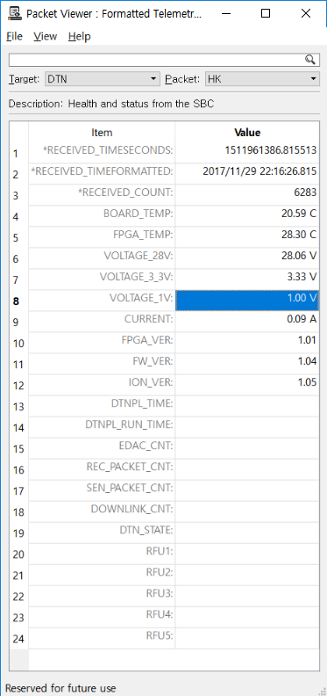
Figure 4.3 State of Health Monitoring

USART Communication
The usart data communication result is shown below.

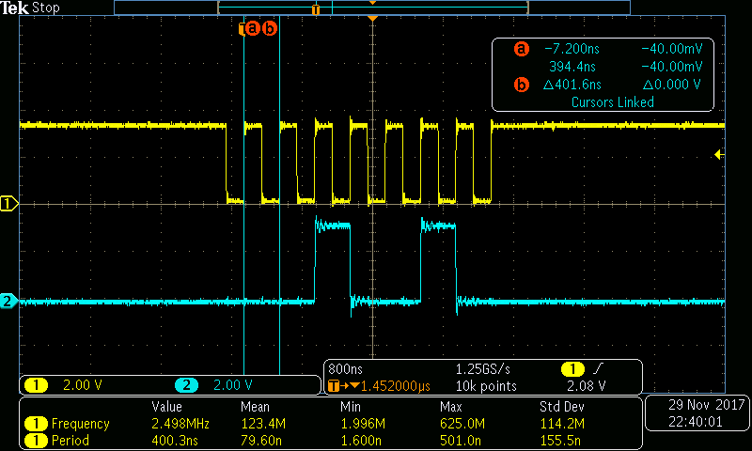
Figure 4.4 USART Communication Result

